**14. Spring MVC - Form Tags and Data Binding**

**Spring MVC JSP Form Tags**:

These Spring MVC form tags give us extra support. They support data binding, so this allows us to automatically set data and retrieve data from Java objects and beans.

As of version 2.0, Spring provides a comprehensive set of data binding-aware tags for handling form elements when using JSP and Spring Web MVC. Each tag provides support for the set of attributes of its corresponding HTML tag counterpart, making the tags familiar and intuitive to use.

**Spring’s Form Tag Library**:

* The form tag
* The input tag
* The checkbox tag
* The checkboxes tag
* The radiobutton tag
* The radiobuttons tag
* The password tag
* The select tag
* The option tag
* The options tag
* The textarea tag
* The hidden tag
* The errors tag
* HTML5 tags

**Configuration**:

The form tag library comes bundled in **spring-webmvc.jar.** The library descriptor is called **spring-form.tld.**

**How to Reference Spring MVC Form Tags**:

To use the tags from this library, add the following directive to the top of your JSP page:

<%@ taglib prefix="form" uri="http://www.springframework.org/tags/form" %>

Where a form is the tag name prefix, we want to use for the tags from this library.

**Spring MVC - Form Tags**:

1. Spring MVC Form Tags are the building block for a web page
2. Form Tags are configurable and reusable for a web page

**Data Binding**:

1. Spring MVC Form Tags can make use of data binding
2. Automatically setting / retrieving data from a Java object / bean

**Spring MVC Form Tags**:

14. Spring MVC - Form Tags and Data Binding

**Spring MVC Form Tags**:

Form tags will generate HTML

|  |  |
| --- | --- |
| **Form Tag** | **Description** |
| form:form | main form container |
| form:input | text field |
| form:textarea | multi-line text field |
| form:checkbox | check box |
| form:radiobutton | radio buttons |
| form:select | drop down list |
| *more ….* |  |

For more info: <https://docs.spring.io/spring/docs/5.0.2.RELEASE/spring-framework-reference/web.html#mvc-view-jsp-tags>

**Web Page Structure**:

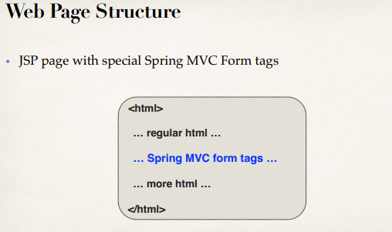

Form tags will generate HTML